Dark Skies Matter to the Wildlife of the St. Lawrence River
Lesson Plan on Light Pollution for Grades 4-6

OVERVIEW & PURPOSE
Gaining an understanding of light pollution and its effects on wildlife can empower students to become advocates for safer, darker night skies in their communities.

EDUCATION STANDARDS
NYS Science Standards: MS-ESS3-3.
NYS Literacy in Science Standards: RST1
NGSS: Core Idea: ETS1.B/MS-ETS1

OBJECTIVES
- To introduce students to the four basic types of light pollution.
- To help students gain an understanding of the risks to wildlife from light pollution, especially nocturnal and migrating species of the St. Lawrence River.
- To give students an opportunity to brainstorm possible solutions to this issue.
- To create an educational poster to share their learning with others.

MATERIALS NEEDED
- Video Light Pollution Effects on Wildlife and Ecosystems - International Dark-Sky Association
- Light Pollution Map - DarkSiteFinder.com
- Light Pollution and Wildlife Brochure and highlighter for each student:
- Posterboard, markers, colored pencils, and other art supplies
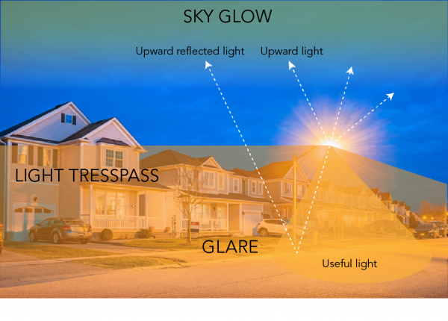
Most of us are familiar with air, water, and land pollution, but did you know that light can also be a pollutant?
The inappropriate or excessive use of artificial light – known as light pollution – can have serious environmental consequences for humans, wildlife, and our climate. Components of light pollution include:

- Glare – excessive brightness that causes visual discomfort
- Skyglow – brightening of the night sky over inhabited areas
- Light trespass – light falling where it is not intended or needed
- Clutter – bright, confusing and excessive groupings of light sources https://www.darksky.org/light-pollution/
Have students brainstorm examples they have experienced or seen any of these types of light pollution.
Glare: Oncoming headlights, bright outside lights that prevent you from seeing clearly at night.
Skyglow: Seeing a city when you’re miles away, Noticing the car dealerships, the Mall, and other brightly lit areas from a distance.
Light trespass: Streetlights or neighbor’s lights shining in your home or yard
Clutter: Multiple sources of light on streets and buildings that make it difficult to see at night

ACTIVITY
Open the lesson with a discussion of the St. Lawrence River and what students know about it, especially the animals, plants, and insects found along its banks. Tell the class that they will be creating posters to highlight the risks of ALAN (Artificial Light at Night) to the ecosystem of the St. Lawrence River.
Watch the video Light Pollution Effects on Wildlife and Ecosystems - International Dark-Sky Association and discuss.
Use the Light Pollution Map - DarkSiteFinder.com to show students where their community and the River are, and to highlight the large areas of the brightly lit night sky along the East Coast of the US and Southern Canada. Point out areas with little night illumination; the Adirondacks, the middle of Lake Ontario, Northern Canada.
Use the brochure to instruct the students on the risks to mammals, birds, amphibians, reptiles, and insects. Using their highlighters, have them first identify animals found in the St. Lawrence River Valley. Examples include bats, raccoons, coyotes, deer, birds, frogs, turtles, moths, and other insects. (Vocabulary list is attached below)
Next, identify some of the risks of light pollution to those species. Urban Skyglow, the bright lights from cities and towns, can completely disrupt nocturnal animals' ecosystems. It can pose deadly consequences to sensitive habitats, such as wetlands and the amphibians that inhabit the marsh environment.
Glare from light sources can attract insects, causing them to expend too much energy which affects their mating and migration and can reduce their population. Insects also can be easier prey for bats, and reducing the insect population negatively affects the entire food web.
Light trespass from useful but excessive artificial light can affect any animals in the vicinity. In the St. Lawrence River area, light trespass can spill unneeded and sometimes dangerous light into homes and habitats.
Clutter of light sources can cause unnecessary glare and difficulty seeing to humans and other species and can contribute to all the other forms of light pollution above.
When students have a good grasp of the types of light pollution, encourage them to make a poster (using the brochure and infographics as inspiration) to educate others about light pollution. Remind them that their posters should clearly show at least one form of light pollution with its negative effects on wildlife.

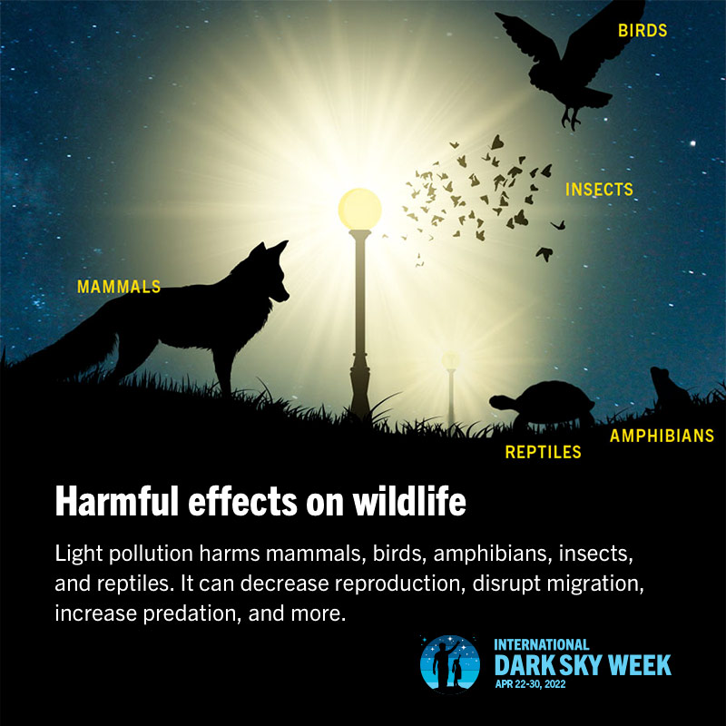
https://www.darksky.org/light-pollution/wildlife/

CHECKING FOR STUDENT UNDERSTANDING
- Can students identify the four types of light pollution? (Skyglow, Light Trespass, Glare, and Clutter)
- Are students able to explain the risks of light pollution on nocturnal animals and migrating birds? (Life-threatening disruptions to migration schedules, predator/prey relationships, reproduction, foraging for food, and other vital components of a related ecosystem)
- Did students complete a poster, demonstrating their knowledge of at least one form of light pollution, and its negative effect on wildlife?
- Do students have a plan for action for their home (Using artificial light at night only as needed by using timers and dimmers, and shutting off lights when not required; choosing yellow or amber lights; shielding lights) and for their community on this issue? (Educating other students, family, and community members by making posters, writing letters, participating in environmental awareness events, and any other activity that will give a vital message to those around them)

OTHER RESOURCES
Light Pollution Infographic.
Glossary - International Dark-Sky Association
The New World Atlas of Artificial Sky Brightness
| CIRESJunior Ranger Booklet from Voyager National Park

You can find a wide variety of lessons on the problems with light pollution available online. Most are free, but some require a subscription.
Dark Sky Classroom — Voyageurs Conservancy
The Dark Sky Classroom is a joint program with the National Park Service that brings the wonder of the night sky and Voyageurs National Park to your classroom! Lesson plans support national and state standards, including the Next Generation Science Standards. (Written for 4th grade, but applicable to other grades)

The Dark Side of Light Physics Article for Students | Scholastic Science World Magazine
OCTOBER 21, 2019 By Kimberly Y. Masibay

Is a brighter world dimming the future for bats?
“Living alongside people isn’t always easy for wildlife. One problem city-dwelling bats face is light pollution. The electric lighting that illuminates cities at night disorients these creatures, which are used to navigating in total darkness. A brighter nighttime environment can also disrupt their cycle of sleeping and waking, as well as interfere with feeding and reproduction. “Light pollution can change behavior in harmful ways for some bat species,” says Frick. Fortunately, researchers, engineers, and city planners are working together to remedy the problem and help bats reclaim the night.”

The Darkest Places on Earth
Scholastic Action Magazine - SEPTEMBER 2022 by Mary Kate Frank

“At spots like Arches National Park in Utah, you can see stars and planets. But scientists fear our beautiful night sky might be disappearing. The world is running out of places dark enough to see stars. When the sun sets, people turn on powerful outdoor lights. They light up homes, office buildings, and sports stadiums. Even when they aren’t needed, beams of light still shine in many places. This overuse of artificial light is called light pollution.

The whole planet is affected by light pollution. That’s why people are taking steps to save the world’s darkest skies.”

Vocabulary From the Light Pollution and Wildlife Brochure
International Dark-Sky Foundation
ALAN- Artificial Light at Night
Artificial Light - Light that is not found in nature, but is produced by humans
Biological Clock - The cycle that animals and plants live by, which they’re born with - inherited through their genes
Circadian Rhythm - For animals, sleep, body temperature, alertness, hunger, hunting and other body functions run on a cycle of about 24 hours called "Circadian Rhythms"
Diminished Population - When the numbers of an animal or plant species go down
Disorientation - Confusion, such as when a bird doesn't know which direction to fly
Ecologically Sensitive Habitats - Areas where plants and animals live that can be easily damaged by human behavior
Excessive -Too much of something, more than is needed
Expending Energy - Using up the energy you might need for something else. For example, a bird using up all its energy trying to follow artificial light
Forage - To hunt for food
Habitat - The natural place animals and plants live in, such as a frog in a marsh
Haze - For light pollution, when artificial light bounces off clouds, fog, smoke, or steam; making it difficult to see
Inherited Trait - When an animal or plant gets a gene from its parents "pre-programming" it to live, grow, or have certain characteristics tied to the gene
Instinct - When animals know how to do something they weren't taught, but were born knowing, such as migrating
Marine Birds - Birds that are adapted to live near the ocean or along the shoreline of rivers and lakes
Migration/Migrating - When animals go back and forth between their winter and summer homes, usually to find food sources
Negative Effect - Something bad that happens because of something that is done
Nocturnal - For animals, species that depend on the night and darkness for hunting
Predator - A predator hunts other animals, which are called prey. Nocturnal predators hunt at night
Reproduction - Producing young, such as frogs producing tadpoles, and birds producing chicks
Vulnerable - In danger of something bad happening, or unable to protect yourself. For example, too much light at night makes some animals in danger of being seen by predators, which could hunt more of them.
Wildlife - Animals in their natural habitats

